

**Sunday Series: 12-5pm - April 28th, May 5th & May 19th**

# Leadership Training Series with

# Lanah K. Hake (Founder Ft. Wayne Outdoor Yoga/Lanahink ) &

# Nikki Myers (Founder CityYoga & Y12SR)

# Fort Wayne, Indiana

✹

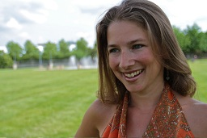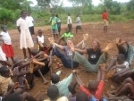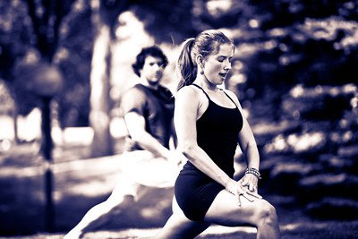

**Yoga In *Action***

**Fort Wayne, Indiana**

**To Register:**

[www.lanahlink.com](http://www.lanahlink.com) click on EVENTS

Register by March 1st = $275, By April 1st = $300, After April 1st = $325

Questions: [Lanah@LanahLInk.com](mailto:Lanah@LanahLInk.com)

This *Yoga In Action* series provides an opportunity to explore our selves and purpose through a combination of yoga practice, discussions and reflection including: (Note, familiarity with yoga is preferred, but you do not need to be advanced yoga student to attend. Yoga teachers, activists, leaders and interested students seeking this purpose work are welcome).

* **Self-Inquiry**: What is my Purpose? What does ‘living on purpose’ look like for me?
* **Interdependence**: What is our connection to world around us, each other?
* **Community**: How can I gain practical tools to enhance communication & connection?
* **Action**: How can we initiate a community project that makes a difference off the mat?

## Yoga, Purpose & Action

✹

# Yoga In Action: Finding your purpose and living it both On and OFF the Mat

# *LanahLink Social Impact Solutions presents….*